Cannabis/Marijuana at Genesee Community College
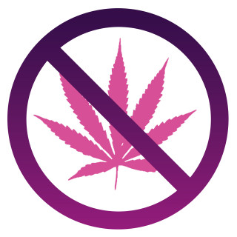
You may not use, possess and/or distribute cannabis/marijuana (including but not limited to medical marijuana and marijuana paraphernalia) or any other cannabis/marijuana products in any form on Genesee Community College (GCC) and College Village properties and/or sponsored event.

Why Cannabis/Marijuana is Not Allowed
Despite the recent passage of the New York State Marijuana Regulation and Taxation Act (MRTA), the use, possession and/or distribution of cannabis/marijuana in any form remains a crime under federal law. At the federal level, the Controlled Substances Act criminalizes the growing, possession and/or use of cannabis/marijuana. As a controlled substance, use, possession and/or distribution of cannabis/marijuana continues to be prohibited by GCC’s Student Code of Conduct and is not permitted on campus and/or sponsored event. The use, possession and/or distribution of cannabis/marijuana on campus is also restricted by federal laws, such as the federal Drug-Free Schools and Communities Act. In short, federal law requires that any College/University prohibit the use, possession and/or distribution of cannabis/marijuana on campus and/or sponsored event due to the federal funding received.

Violations of College Policies
Students who are addressed for violation(s) of of College Policies of the Student Code of Conduct associated with any controlled substance will be referred to the Dean of Students Office for disciplinary action.

Health & Safety
The health and safety of students is always our highest priority at GCC. Drug overdose or alcohol poisoning is a medical emergency. Call Campus Safety 585-345-6500 or 911 immediately in the event of an emergency! The Policy for Alcohol/Drug Use Amnesty - Genesee Community College was developed to minimize any hesitation students may have in obtaining help for themselves or others due to concerns that their own behavior may be a violation of the Student Code of Conduct and/or law.

Remember
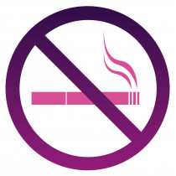No smoking
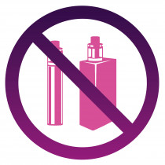No vaping
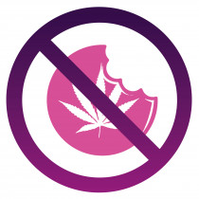No Edibles
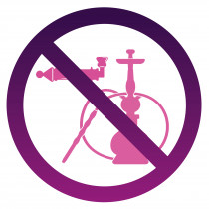No Paraphernalia

